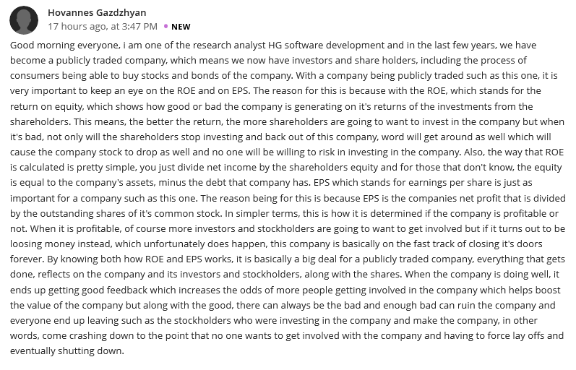Reply 1
Hi Gazdzhyan
To some extent, I would disagree with your definition of what an ROE is. In my opinion, Return on Equity could be identified as a ratio that measures the amount of return a company’s common stock owners are likely to gain from their shareholdings. Ideally, the concept of ROE initiating an insight into the managerial performance of a company does not meet the interests of shareholders. Instead, higher ROE implies that a company is likely to yield more revenue to its investors and not the capability of an organization’s management. In addition to your sentiments on EPS, I would also contribute by claiming the Earnings Per Share provides vital information to an investor's decision-making process. Through understanding the probable earnings a shareholder would gain from each share of a company; it becomes easier to identify the number of shares an investor will buy from a company's common stock.

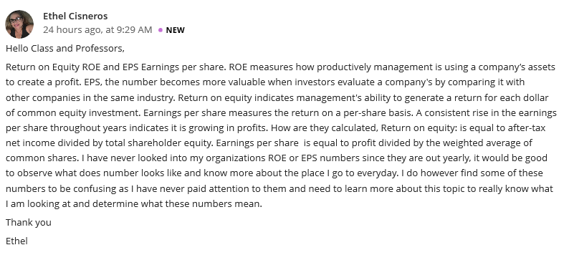
Reply 2
Hello Ethel, you provide a unique insight into what an EPS is. Your claim that this information is utilized by investors to evaluate a company's likability compared to other companies is impressive than what is commonly referred to as its use in informing a firm’s management and shareholders on the company’s profitability. The belief that EPS indicates a company's profitability is not entirely true since not all profits are distributed among investors; only a portion of the profits is allocated to investors' shares. In as much as most of your discussion was focused on EPS compared to ROE, I would add that, the Return on Equity indicates what amount of capital is left in an organization should it decide to settle all of its liabilities at one point. This is because a difference between a company's assets and liabilities will have been provided through the ROE ratio.

